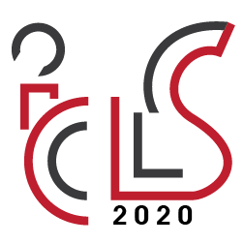15th International Congress of Logistics and SCM Systems (ICLS 2020), July 1~3, 2020 Poznan, Poland
Title: The ICLS 2020 - Abstract template
Author/-s: surname, name author 1; affiliation, email address;
surname, name author 2, affiliation, email address;
surname, name author n, affiliation, email address.
Corresponding author: address, email address
Keywords: please provide 4-6 keywords
The abstract should be between 200-300 words, for submission please follow the on-line submission system: http://icls2020.put.poznan.pl/submission/
Please use the template to prepare the abstract. The abstract should as informative as possible and it should consist of four parts:
1) Introduction, 2) aim, 3) originality/novelty, 4) research methods and data.
References should be avoided, but if essential, then please cite the author(s) and year(s). Non-standard abbreviations should be avoided, but if essential they must be defined at their first mention in the abstract.
Introduction: Please briefly explain the background of your research and/-or motivation to conduct the studies, which are presented in this paper.
Aim: Please briefly explain the main goal of your paper and how it is relevant to the scope of the ICLS 2020 conference
Originality/novelty: Please explain what is novel in your approach? How your approach is new/extended in comparison to the other related studies and/-or your previous publications on related topic/-s?
Research methods and data: Please briefly describe the research methods and data used in this paper. What is the research approach? Are the studies theoretical or empirical? Do you use primary or secondary data? etc.
If you have any questions, please don’t hesitate to contact us: icls2020@put.poznan.pl

